**4.3 PRACTICE**

M.Mahathi

192324098

TASK 1:

package triangle;

import java.util.Scanner;

public class triangle {

public static void main(String[] args) {

Scanner scanner = new Scanner(System.***in***);

System.***out***.print("Enter the base of the triangle: ");

double base = scanner.nextDouble();

System.***out***.print("Enter the height of the triangle: ");

double height = scanner.nextDouble();

double area = 0.5 * base * height;

System.***out***.println("The area of the triangle is: " + area);

}

}

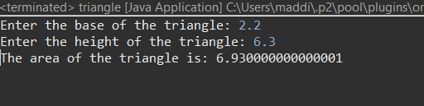

TASK 2:

package formulae;

public class MathFormulas {

public static void main(String[] args) {

// Assume x, y, z are already initialized

double x = 2.0;

double y = 3.0;

double z = 4.0;

// a. a = sqrt(x^5 - 6) / 4

double a = Math.*sqrt*(Math.*pow*(x, 5) - 6) / 4;

System.***out***.println("a = " + a);

// b. b = xy - 6x

double b = x * y - 6 * x;

System.***out***.println("b = " + b);

// c. c = 4 * cos(z / 5) - sin(x^2)

double c = 4 * Math.*cos*(z / 5) - Math.*sin*(Math.*pow*(x, 2));

System.***out***.println("c = " + c);

// d. d = x^4 - sqrt(6x - y^3)

double d = Math.*pow*(x, 4) - Math.*sqrt*(6 * x - Math.*pow*(y, 3));

System.***out***.println("d = " + d);

// e. e = 1 / (y - 1 / (x - 2y))

double e = 1 / (y - 1 / (x - 2 * y));

System.***out***.println("e = " + e);

// f. f = 7 * (cos(sqrt(5) - sin(sqrt(3x - 4))))

double f = 7 * (Math.*cos*(Math.*sqrt*(5)) - Math.*sin*(Math.*sqrt*(3 * x - 4)));

System.***out***.println("f = " + f);

}

}

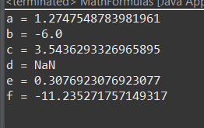

TASK 3:

package transportation;

import java.util.Scanner;

public class Transportation {

public static void main(String[] args) {

Scanner scanner = new Scanner(System.***in***);

System.***out***.print("Enter the number of people signed up for the trip: ");

int people = scanner.nextInt();

int busCapacity = 45;

int busesNeeded = people / busCapacity;

int peopleInVans = people % busCapacity;

System.***out***.println("Number of buses needed: " + busesNeeded);

System.***out***.println("Number of people that will need to ride in vans: " + peopleInVans);

}

}

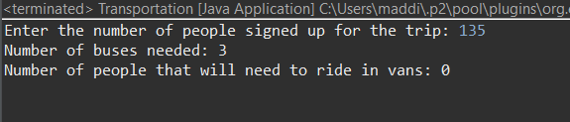

TASK 4:

package booleanexpressions;

public class BooleanExpressions {

public static void main(String[] args) {

int i = 5;

int j = 6;

boolean true_false;

true_false = (j < 5); // false

System.***out***.println(true_false);

true_false = (j > 3); // true

System.***out***.println(true_false);

true_false = (j < i); // false

System.***out***.println(true_false);

true_false = (i < 5); // false

System.***out***.println(true_false);

true_false = (j <= 5); // false

System.***out***.println(true_false);

true_false = (6 < 6); // false

System.***out***.println(true_false);

true_false = (i != j); // true

System.***out***.println(true_false);

true_false = (i == j || i < 50); // true

System.***out***.println(true_false);

true_false = (i == j && i < 50); // false

System.***out***.println(true_false);

true_false = (i > j || true_false && j >= 4); // true

System.***out***.println(true_false);

true_false = (!(i < 2 && j == 5)); // true

System.***out***.println(true_false);

true_false = !true_false; // false

System.***out***.println(true_false);

}

}

